How to add a Custom Bay of Plenty Zoom Background

First: make sure you are using the latest version of Zoom

- Visit www.bayofplentynz.com/bop-zoom-backgrounds
- Scroll through images and click on the ones you want to download, right-click and save it to your computer
- If you’re not already in a Zoom meeting and want to set this up in advance, open Zoom and click on “New meeting”. Make sure you’ve selected “Start with video”.
- OR if you’re already in a meeting, head to the bottom left of Zoom and click on the arrow pointing upwards. It’s to the right of “Stop Video”. Then click Video Settings…”
- Click “Virtual Background”
- Make sure the button "I have a green screen" is unselected (i.e. not ticked).

- Click “+” to the right of “Choose Virtual Background”. Then click “Add Image”.
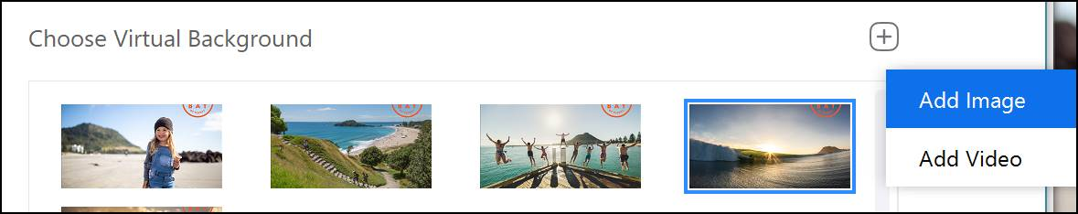

- Find where you saved your chosen background you downloaded and select it. Click “open”.
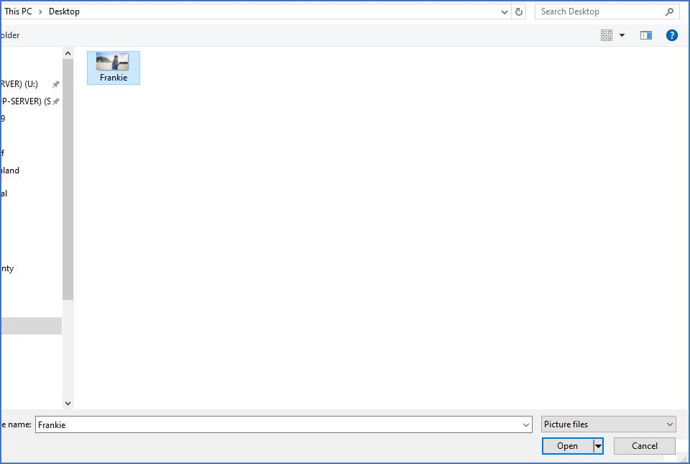

You should now be seeing the beautiful Coastal Bay of Plenty in your Zoom background.

Click here for more troubleshooting options if your background isn’t displaying properly. Please note: you need a reasonably clear background behind you (ideally a blank wall).

