GOOGLE MY BUSINESS ESSENTIALS DURING COVID-19

This paper will provide some clarity for business owners and managers regarding their options and best practices for using Google My Business (GMB) during New Zealand’s Covid-19 Level 4 Restriction period and beyond.

Should I mark my business in GMB as Temporarily Closed?
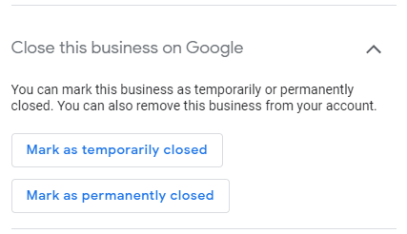
In response to the COVID-19 crisis, Google has added a new option to your GMB profile to “mark as temporarily closed.” While technically every non-essential business in New Zealand currently falls into this category, you should be aware that “temporarily closed” businesses will have reduced exposure in Google’s products - which means you’re less likely to show up when someone searches for your business or your category of business in maps or search during the Level 4 restrictions. If you want the quickest route to update your listing, you can simply click the temporarily closed button and come back and turn your business back on when restrictions are lifted. However, if you don’t mind a few extra steps, we recommend you take a different approach:

RECOMMENDATION: Leave your business hours as they would typically appear and use the “special hours” function to mark each day of the next four weeks as “closed”. You can access special hours in the “info” section of the web app, or the “profile” section of the Google My Business mobile app.
Add a new date at the bottom of the list and mark that day as closed.
While it can be a bit tedious to add thirty days to the list, using this approach will mean your business profile maintains exposure in maps and other Google products during this time. You can then continue to use Posts and other features described below.
What if I get a notice from Google that my business has been marked as temporarily closed?

Some areas of the world have seen bulk updates and businesses marked as temporarily closed by Google. If you see an email about this from Google, log in to your Google My Business account and look for this banner at the top of the “Info” page.
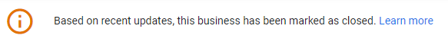
These bulk updates are the result of information coming in from authoritative data sources, including government agencies. Quote from Google’s support page on this subject:

“We rely on authorities to tell us when there are closures in their region. Authorities can provide this through our Geo Data Upload tool. We use data from many types of authoritative data sources, which include national, state/provincial and local governments, non-profit organizations, educational institutions, and businesses.”
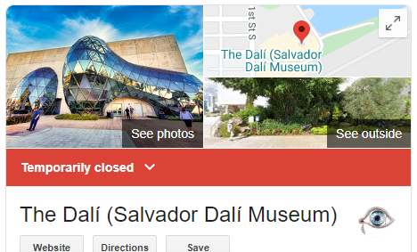
Up to you if you want to change the status of your business and use the recommended “special hours” approach above. Note that the example to the right shows what your profile will look like in Google when marked as temporarily closed.

What features are and aren’t available in Google My Business due to COVID-19?
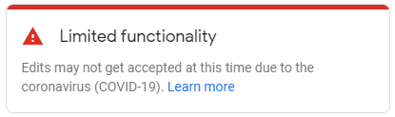
When you log in to Google My Business, you’ll note several updates which indicate limited functionality is available. Here’s a quick summary:

- Questions and Answers have been removed from business profiles temporarily. This means customers won’t be able to see existing questions and answers, and can’t ask any new questions.

- New reviews CAN be posted by customers, but are likely to be delayed. In our tests we found that the review count and ratings appeared instantly, but the written comment portion of the review was delayed (sometimes significantly) in appearing.

- Curiously, even though reviews can be added during this time, Review Replies from owners are disabled. Owners CAN NOT respond to reviews, new or old for the time being.
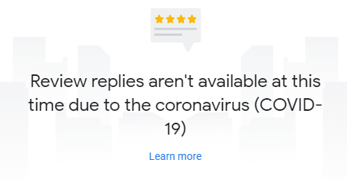

- Updates to open/closed status and updates to hours are prioritized for review by Google at this time. All other edits to your profile information - including updating your name, your address, your pin location, categories, etc. will be delayed.

- You may have read a few weeks ago about changes to the moderation process of all photos submitted to GMB and maps. This change was expected to slow the approval of published images, and will no doubt be further slowed by the COVID-19 crisis. You should feel free to post photos - but don’t expect them to appear quickly. Reference article: https://www.seroundtable.com/google-my-business-to-review-all-photos-videos-before-publication-29113.html

IMPORTANT NOTE: During this time, making anything more than minor changes to your business profile may result in your profile being flagged for review. Our best advice for now, is to keep as much of your profile information as consistent as possible. This includes:
- Business Name
- Categories
- Pin Location
- Address
- Service Areas
- Phone Numbers
- Websites
- Attributes

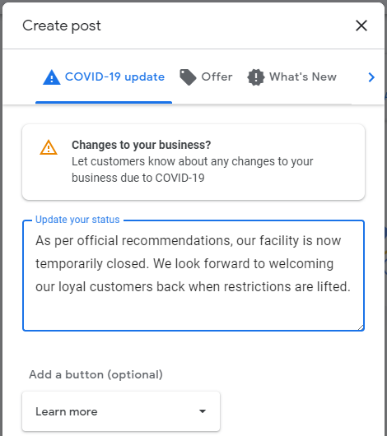
What can I do during this time?

Apart from updating your hours as recommended above, your best option is to use the Posts feature, which is currently operating as normal. (Note that unfortunately Hotels do not have access to the Posts feature).

Posts are a great way to keep up to date information about your business front and centre. For example, if you’re still able to deliver some products, you can provide that information as a post, or you can simply use the new “COVID-19 update” option to provide a quick note in support of your community during this time.

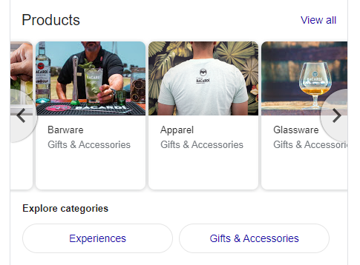
This is also a good time to set up the “products”, “services” or “menu” feature in your profile, adding categories, photos products and prices. In our tests, products appeared quickly - between 20 minutes and one hour. Even if you don’t have products that

can currently be purchased, it’s an excellent time to get things configured, tested and set up before customers return.

How should I prepare for customers to return?

When it becomes clear that the restrictions will be lifted, you’ll want to quickly make sure that the following information is up to date:

- Hours - make sure hours are accurate
- Posts - add a post to let people know that you are in fact open starting on a specific date
- Questions and Answers - once Q&A returns, you’ll want to add some specific questions and answers of your own to let people know about changes to your products or services
- Reviews - it looks like the reviews submitted during this crisis may simply be held until a later date, which could mean you have a surge of reviews which will need to be responded to as soon as the reply capability is reinstated.

Further Resources:
- For more help & information on Google My Business: https://business.google.com
- For essential updates and official information on New Zealand’s response to the Covid-19 crisis: https://covid19.govt.nz/

Summary from Miles Partnership South Pacific working in cooperation with your RTO.

